RAILWAY RESERVATION (REGISTRATION,LOGIN AND RESERVATION)

PROJECT- RAILWAY RESERVATION SYSTEM

SUB-PROJECT-REGISTRATION, LOGIN AND RESERVATION

DATA BASE TABLES: YPDBD (PASSENGER DATABASE TABLE), YTDB (TRAIN DTBASE TABLE).

ASSUMPTIONS:

1. THE AVAILABLE TRAINS ALONG WITH THEIR SOURCE AND DESTINATION LOCATIONS ARE SPECIFIED IN THE TRAIN DATA BAS TABLES.
2. THE PASSENGER ID IS SELF GENERATED BY THE PASSENGER HIMSELF/HERSELF WHILE REGISTRATION.
3. THERE ARE ONLY TWO GENDERS (MALE AND FEMALE) TAKEN INTO CONSIDERATION WHILE REGISTERATION.
4. THE ACCEPTABLE E-MAIL IDS SHOULD BE ONLY OF GOOGLE MAIL.
5. THE PASSWORD SET BY THE USER IS OF NUMERIC CHARACTERS ONLY.

SCREENS:

SCREEN 1: MAIN SCREEN

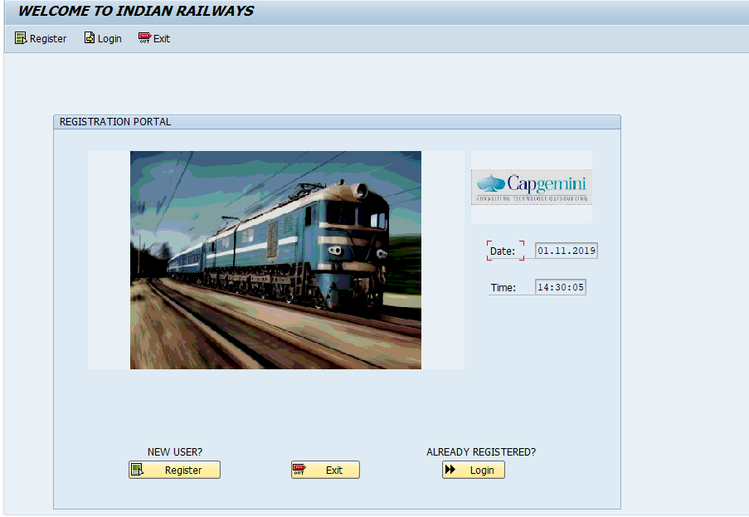

HERE THE USER IS PROVIDED WITH OPTIONS TO EITHER REGISTER IF HE IS A NEW USER OR TO LOGIN IF HE IS ALREADY REGISTERED IN THE PORTAL.

SCREEN 2: REGISTRATION SCRREN

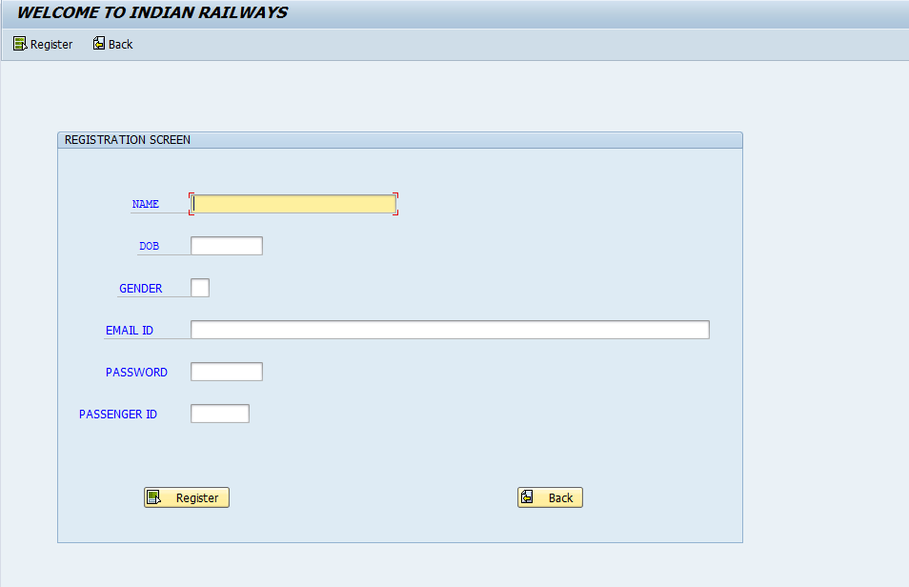

HERE THE USER HAS TO ENTER ALL THE FIELDS TO REGITER HIMSELF IN THE PORTAL.

INVALID CASES:1)

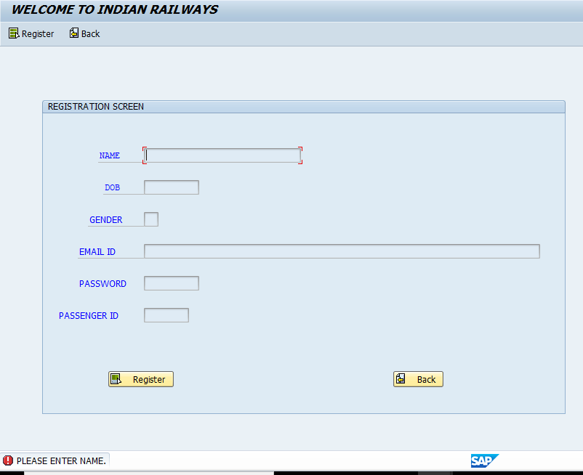  
WHEN THE USER TRIES TO REGISTER WITHOUT ENTERING ANYTHING.

MSG-PLEASE ENTER NAME.

SIMILARLY FOR OTHER FIELDS TOO, THERE ARE REQUIRED ERROR MESSAGES IF THEY ARE LEFT ALONE.

2) 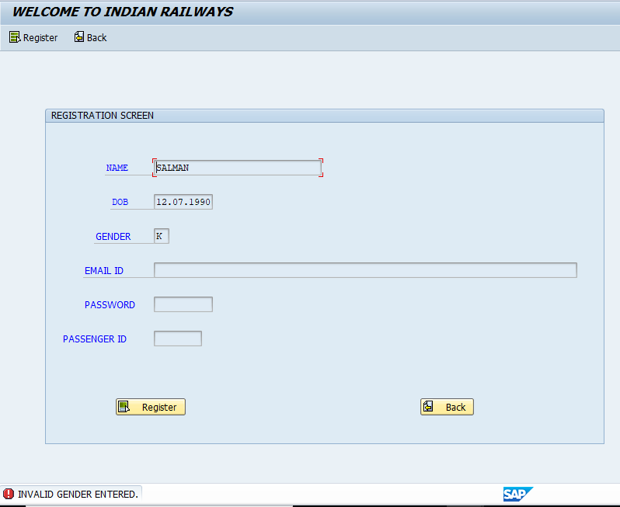

WHEN THE USER ENTERS ANY OTHER GENDER THAN MALE(M) OR FEMALE(F).

MSG-INVALID GENDER ENTERED.

3)

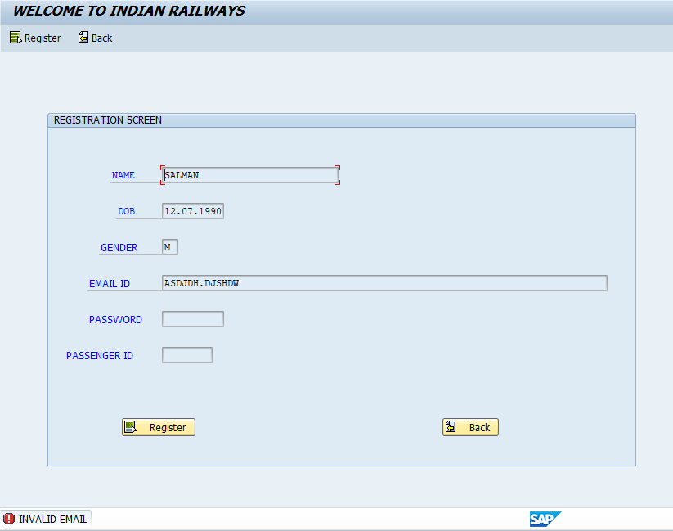

WHEN USER TRIES TO ENTER AN INVALID MAIL ID.

MSG-INVALID MAIL.

4) 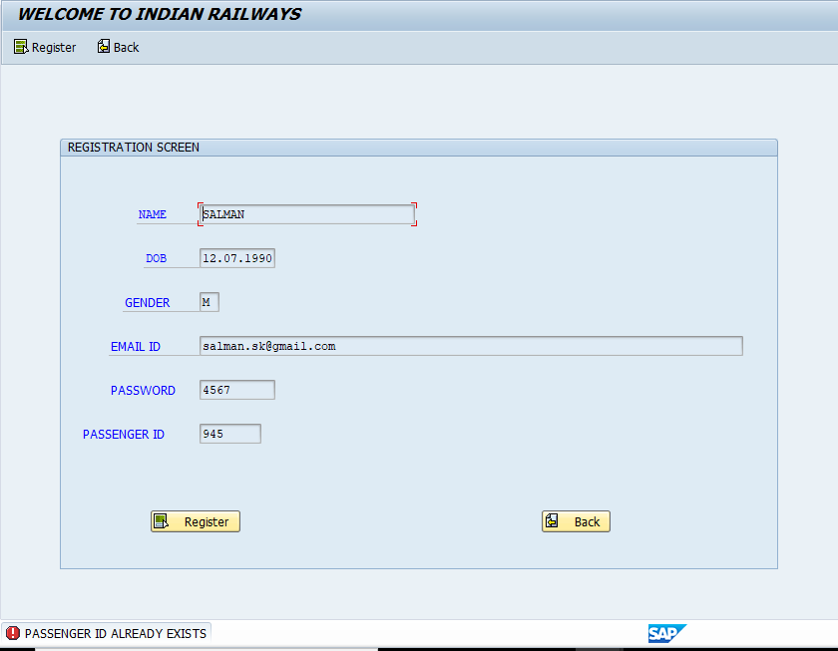

WHEN THE USER ENTERS AN ID THAT ALREADY EXISTS IN THE DATABASE.

MSG-PASSENGER ID ALREADY EXISTS.

5) 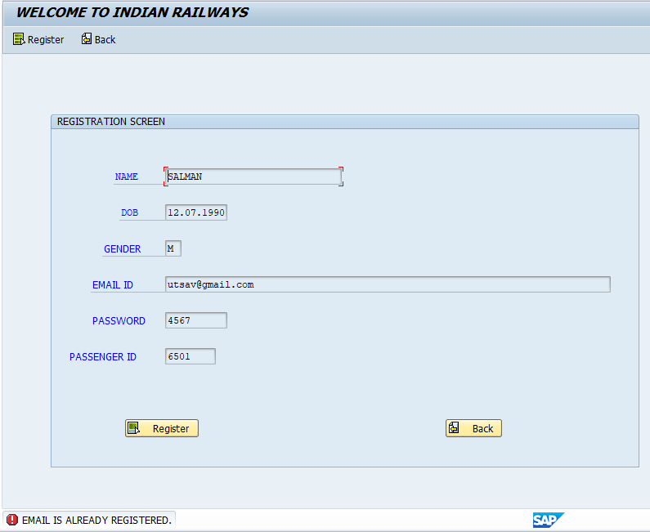

WHEN THE USER ENTERS AN EMAIL ID THAT IS ALREADY REGISTERED.

MSG-EMAIL ALREADY REGISTERED.

6) 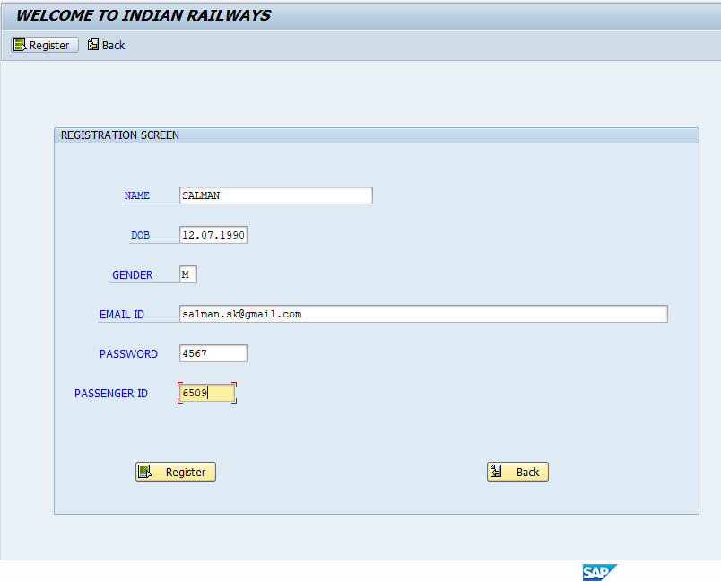

SUCCESSFUL REGISTRATION INPUTS.

SCREEN 3: THANK YOU SCREEN FOR REGISTERING.

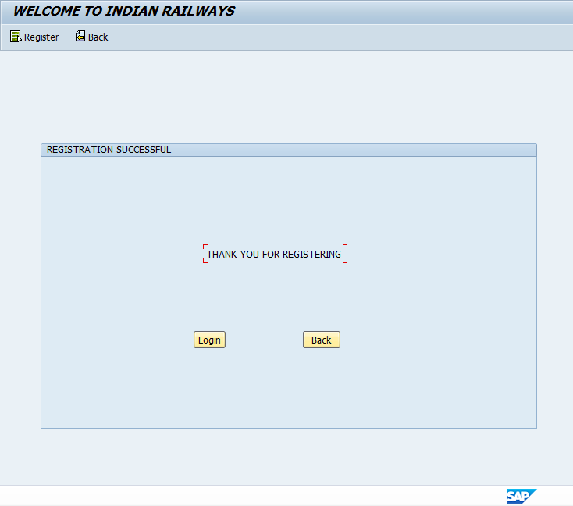

WHEN THE USER INPUTS ALL VALID INPUTS IN THE REGISTRATION SCREEN.

SCREEN 4:LOGIN SCREEN

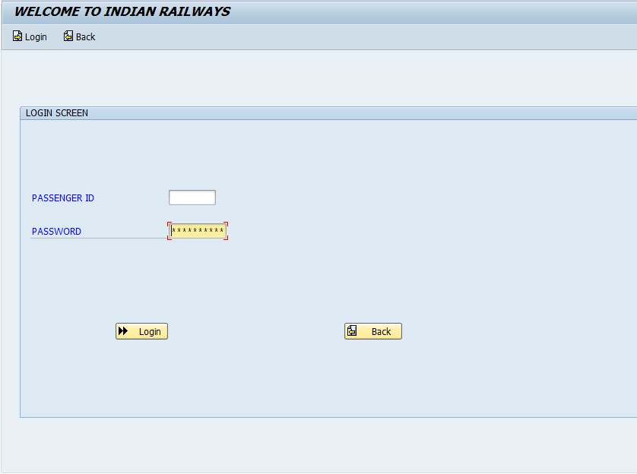

HERE THE USER IS ASKED ABOUT THE PASSENGER ID AND PASSWORD WITH WHICH HE HAD REGISTERED.

FOR INVALID ENTRIES-

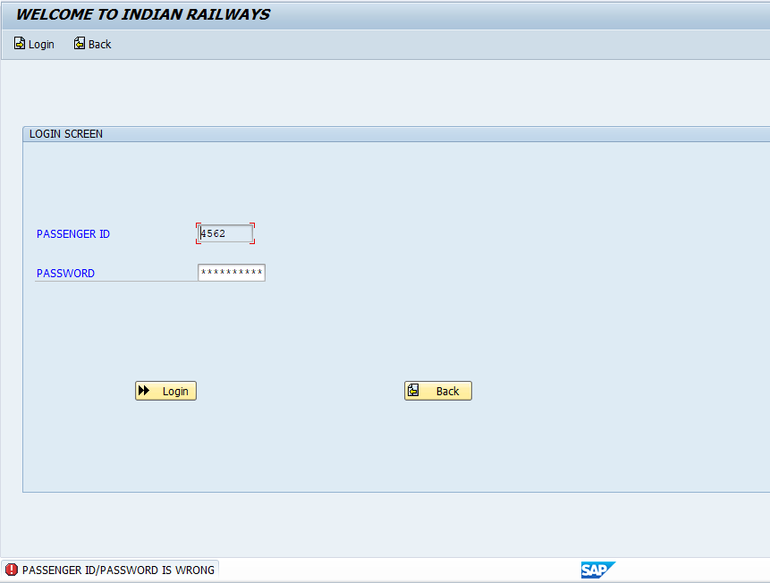

FOR WRONG ID AND PASSWORDS

MSG-PASSENGER ID/PASSWORD IS WRONG.

SCREEN 5: AVAILABILITY SCREEN-

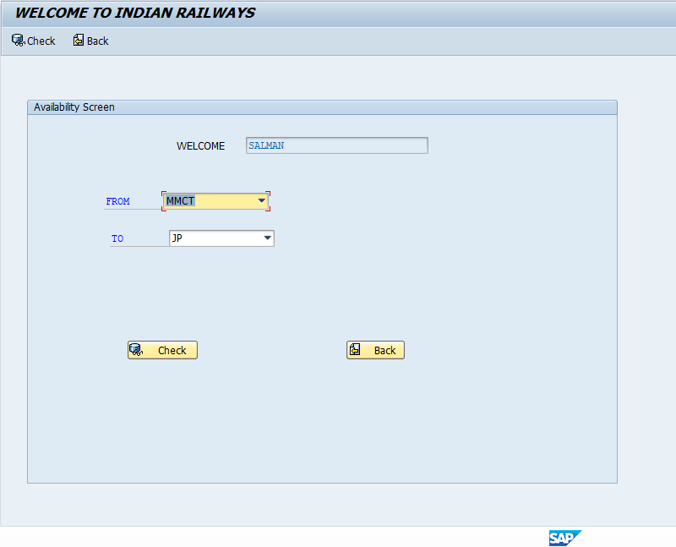

HERE THE USER IS GIVEN OPTION TO CHOOSE THE SOURCE AND DESTINATION PLACES.

IN THE DROP DOWN, WHEN WE SELECT A SOURC PLACE ITS CORRESPONDING DESTINATION PLACE APPEARS IN THE TO DROP DOWN.

SCREEN 6: AVAILABLE TRAINS SCREEN.

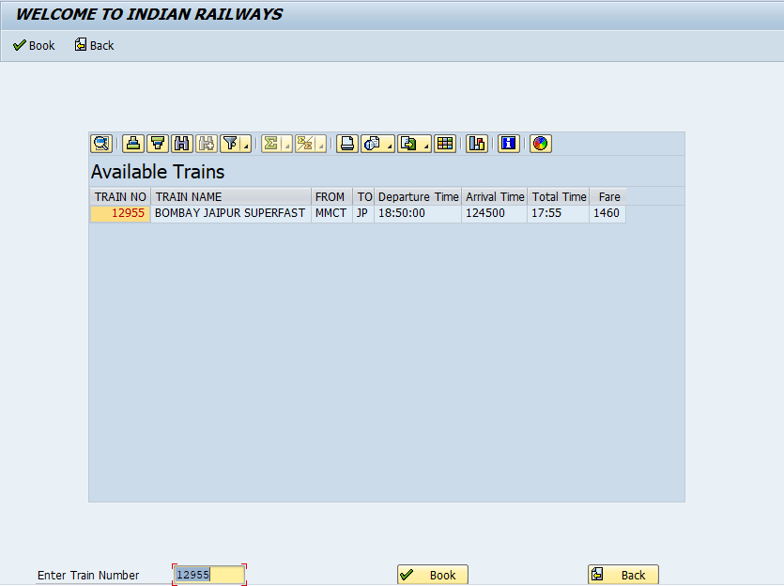

IN THIS SCREEN ALL THE AVAILBLE TRAINS ARE DISPLAYED ACCORDING TO THE TO AND FROM PLACES SELECTED BY THE USER.

SCREEN 7: CONFIRMATION SCREEN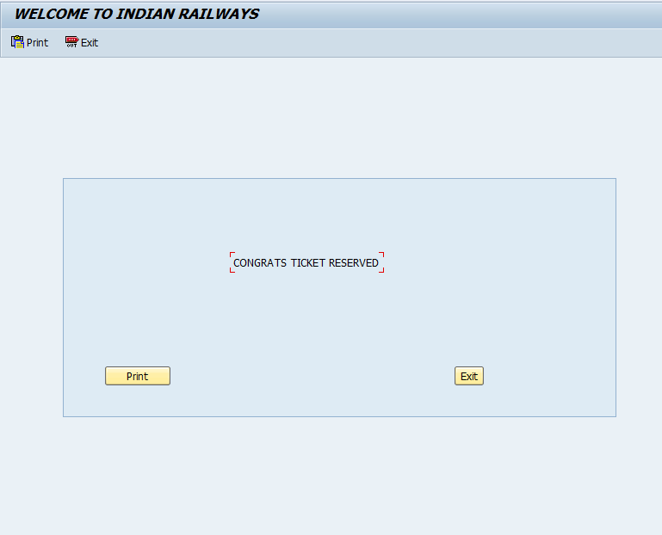

HERE THE TICKET OF THE PASSENGER IS CONFIRMED.

TICKET PRINT(ADOBE FORM)-

